***Hands-On Exercise 1.1: My first HTML program (:10 min):***

1.❑ Open Notepad++ and type the code below. Save it as “Exercise1.html”, ensure that your file extension is .html and not .html.txt (without you knowing.)

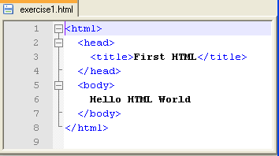

2.❑ Copy and paste your code below.

|  |
| --- |
| <html>  <head>  <title> First HTML </title>  </head>    <body>  Hello HTML World!!  </body>  </html> |

3.❑ Run your program using Internet Explorer (or Microsoft Edge), or other modern browsers. Take a snippet of your output and paste below.

|  |
| --- |
| Hello HTML World!!  file:///C:/Users/008023225/Desktop/exercise%201.html |

4.❑ Run your program using a different browser than the one you use in Step #3. Paste below the output from another browser type.

|  |
| --- |
| file:///C:/Users/008023225/Desktop/exercise%201.html |

[](http://images.google.com/imgres?imgurl=www.skyscript.co.uk/im/trophy.jpg&imgrefurl=http://www.skyscript.co.uk/im/&h=214&w=180&sz=6&tbnid=ECCiP8U-7NsJ:&tbnh=99&tbnw=84&prev=/images?q=trophy&svnum=10&hl=en&lr=&ie=UTF-8&oe=UTF-8&sa=G)Congratulations! You’ve just coded your first HTML page.

1. Write your **name** here: _Cesar Santana________________________
2. Put **date** here: __10/03/2023_____________